Test Case: tc002_SPX_Dev5_Crear_Requisicion_Spot_Tipo_Cobro_Project
Step 1 - Enter username and password and click to button Enter: Credentials Entered
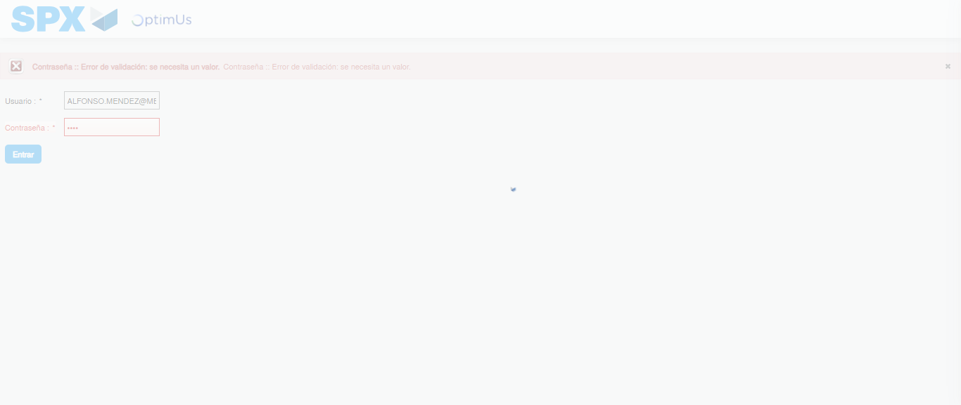Image file-name: QC_Testing-tc002_SPX_Dev5_Crear_Requisicion_Spot_Tipo_Cobro_Project-1783377937544

Step 2 - Select to UEN and Access to Spot Buy Requisitions : UEN Correctly selected and Correct access
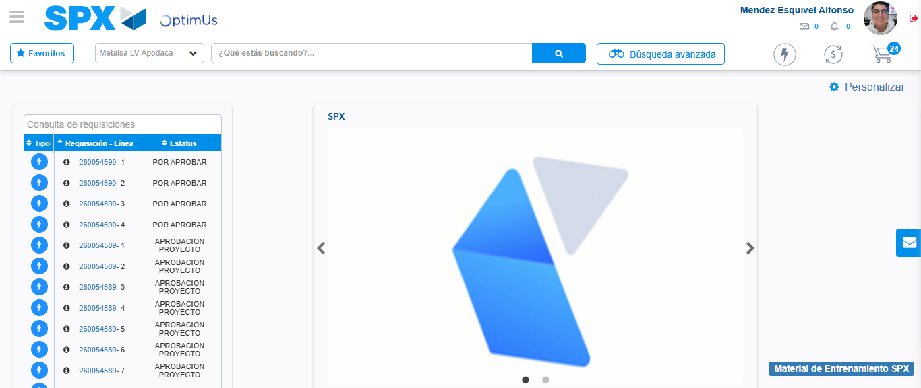Image file-name: QC_Testing-tc002_SPX_Dev5_Crear_Requisicion_Spot_Tipo_Cobro_Project-1783377962384

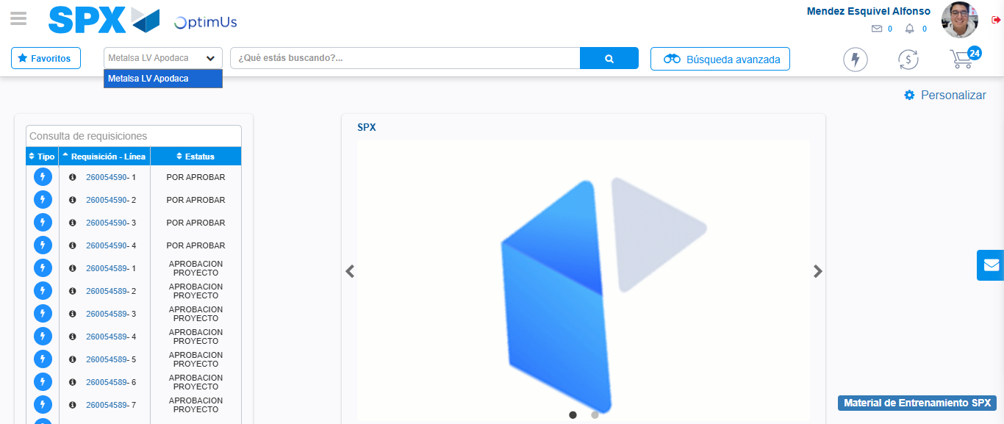Image file-name: QC_Testing-tc002_SPX_Dev5_Crear_Requisicion_Spot_Tipo_Cobro_Project-1783377964858

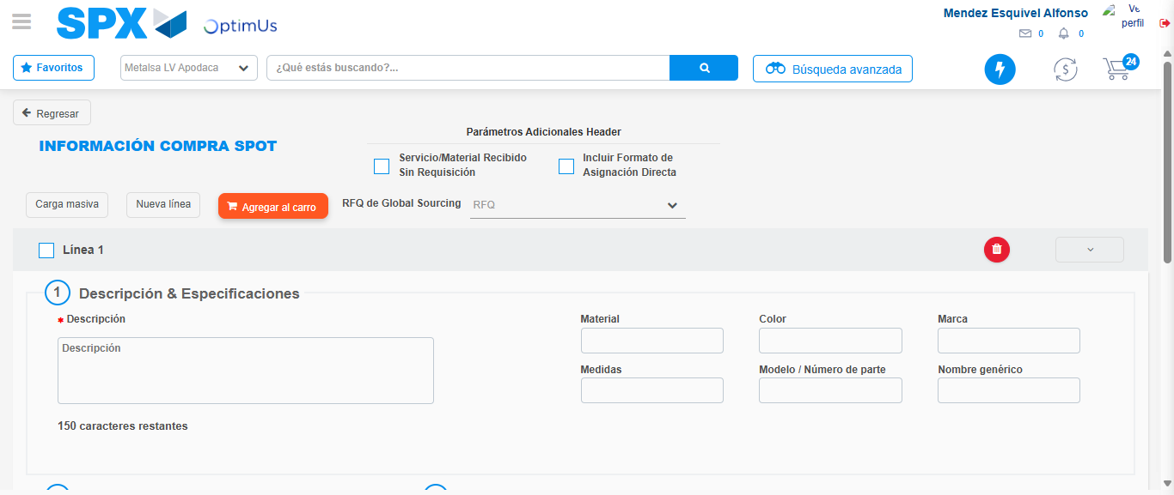Image file-name: QC_Testing-tc002_SPX_Dev5_Crear_Requisicion_Spot_Tipo_Cobro_Project-1783377987284

Step 3 - Data Capture Spot Buy Requisition: Data captured correctly
Image file-name: QC_Testing-tc002_SPX_Dev5_Crear_Requisicion_Spot_Tipo_Cobro_Project-1783377987531

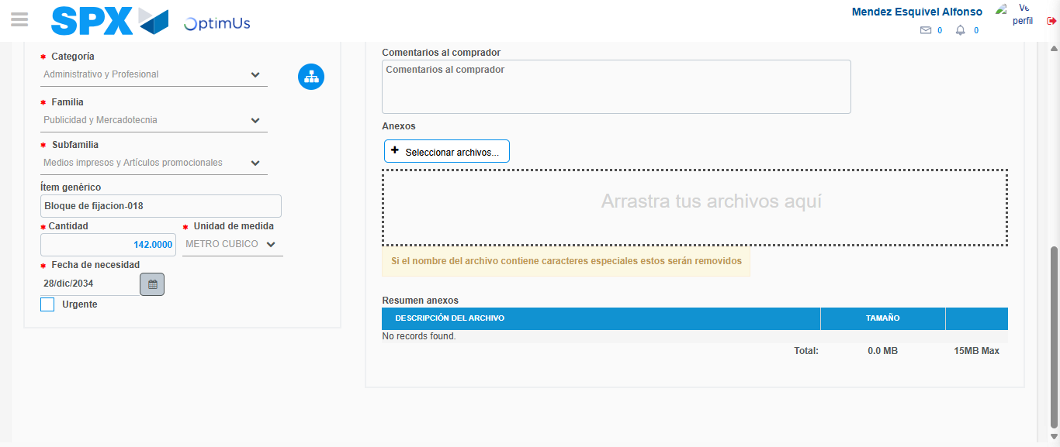Image file-name: QC_Testing-tc002_SPX_Dev5_Crear_Requisicion_Spot_Tipo_Cobro_Project-1783377997365

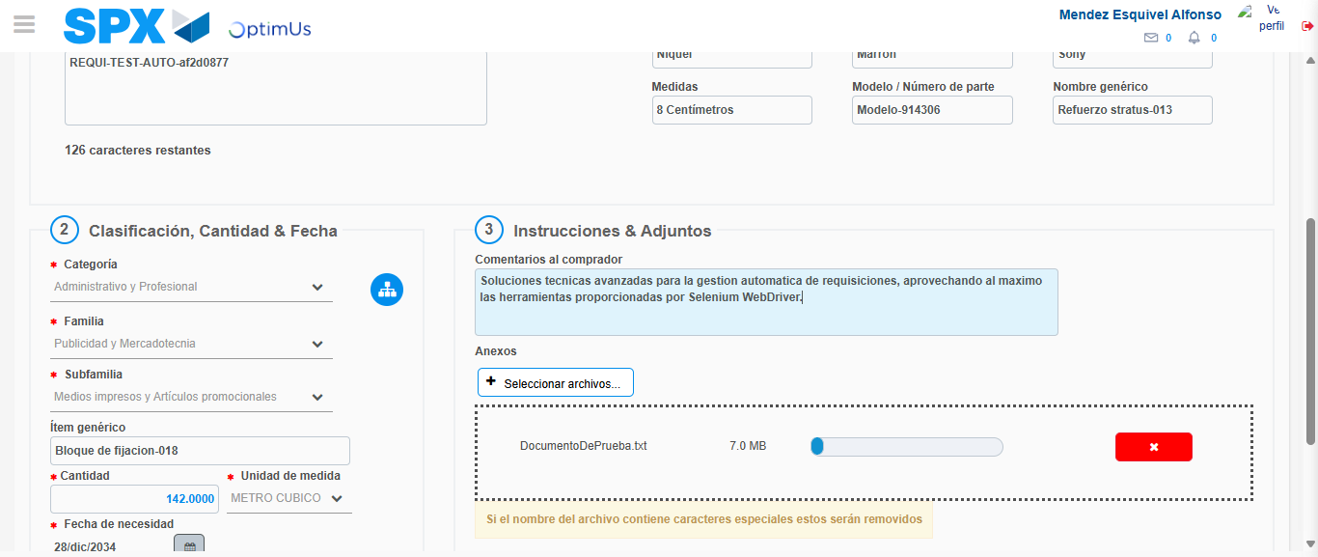Image file-name: QC_Testing-tc002_SPX_Dev5_Crear_Requisicion_Spot_Tipo_Cobro_Project-1783377998140

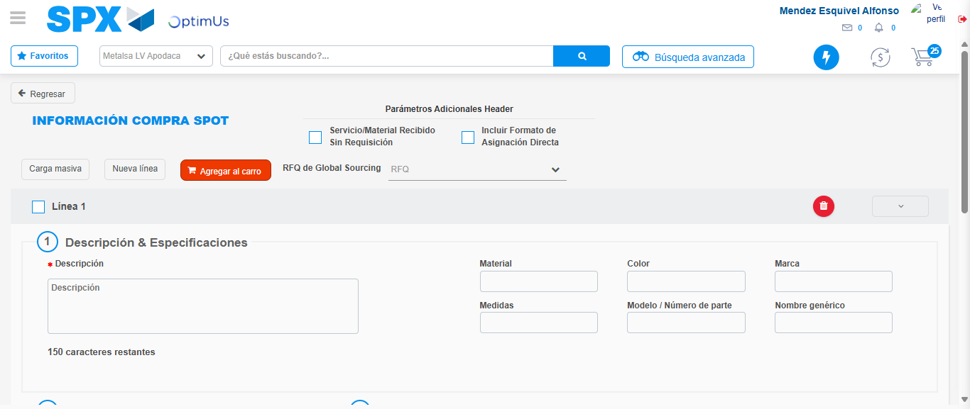Image file-name: QC_Testing-tc002_SPX_Dev5_Crear_Requisicion_Spot_Tipo_Cobro_Project-1783378005026

Step 7 - Return to Main Page SPX : Return to Main Page SPX
Image file-name: QC_Testing-tc002_SPX_Dev5_Crear_Requisicion_Spot_Tipo_Cobro_Project-1783377962384

Image file-name: QC_Testing-tc002_SPX_Dev5_Crear_Requisicion_Spot_Tipo_Cobro_Project-1783377964858

Image file-name: QC_Testing-tc002_SPX_Dev5_Crear_Requisicion_Spot_Tipo_Cobro_Project-1783377987284

Image file-name: QC_Testing-tc002_SPX_Dev5_Crear_Requisicion_Spot_Tipo_Cobro_Project-1783378007260

Image file-name: QC_Testing-tc002_SPX_Dev5_Crear_Requisicion_Spot_Tipo_Cobro_Project-1783378007418

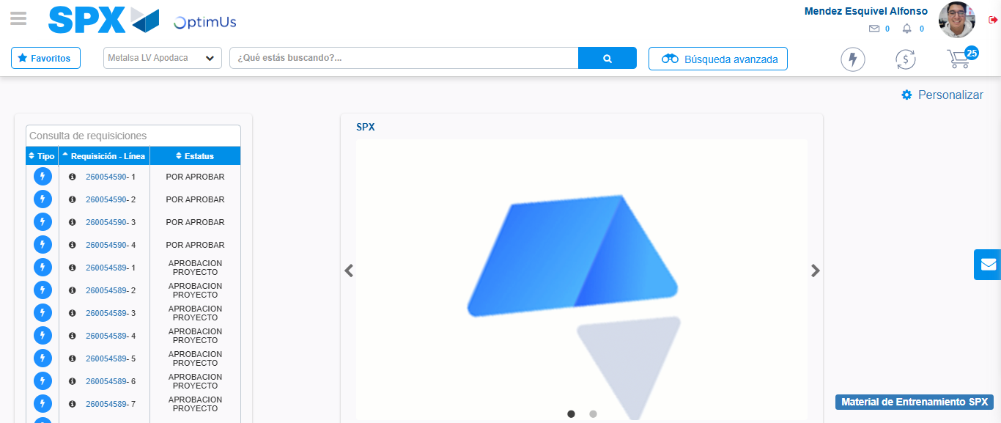Image file-name: QC_Testing-tc002_SPX_Dev5_Crear_Requisicion_Spot_Tipo_Cobro_Project-1783378028578

Step 8 - Log Out : Log Out SPX
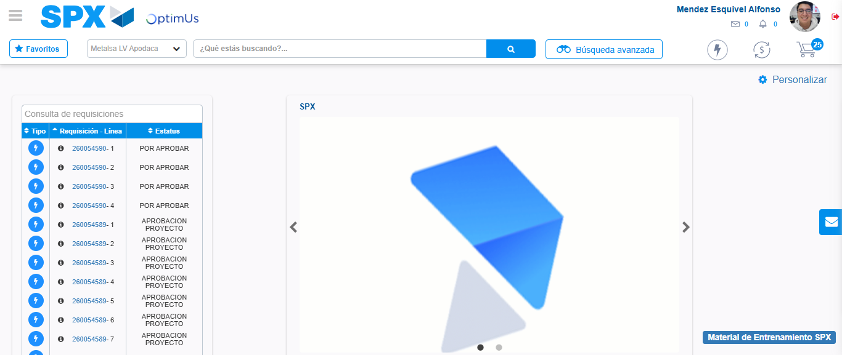Image file-name: QC_Testing-tc002_SPX_Dev5_Crear_Requisicion_Spot_Tipo_Cobro_Project-1783378028823

